404. Sum of Left Leaves
Easy

Given the root of a binary tree, return the sum of all left leaves.
A leaf is a node with no children. A left leaf is a leaf that is the left child of another node.

Example 1:
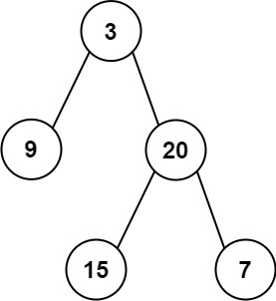
Input: root = [3,9,20,null,null,15,7]
Output: 24
Explanation: There are two left leaves in the binary tree, with values 9 and 15 respectively.
Example 2:
Input: root = [1]
Output: 0

Constraints:
- The number of nodes in the tree is in the range [1, 1000].
- -1000 <= Node.val <= 1000

